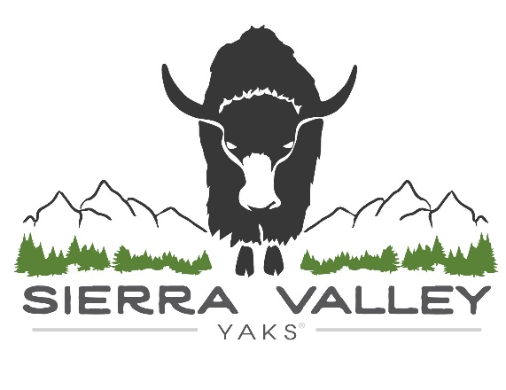
Steaks (per pound) |  | Roasts (per pound)
Filet Mignon | $24 | Tri-Tip | $16
Rib Eye (boneless) | $22 | Brisket | $12
New York | $20 | Chuck | $12
Flat Iron | $16 | Sirloin Tip | $12
Flank | $16 | Cross Rib | $12
Skirt | $16 | Rump | $10
Top Sirloin | $16

Other Cuts (per pound)

Short Ribs/Back Ribs $12

Asada $12

Ground $10

Shank $5

